TEST REPORT
Engineering Recommendation G100
Issue 2 2022 Amendment 1
Technical Requirements for Customers’ Export and Import Limitation Schemes
Testing Laboratory : Shenzhen Growatt New Energy Co., Ltd
Address : 4-13th Floor, Building A, Sino-German Europe Industrial Demonstration Park, No. 1, Hangcheng Avenue, Bao'an District, Shenzhen, Guangdong, China.
Tel ：+86 755 2951 5888 Web site ：www.growatt.com
Test specification:
Standard : G100 Issue 2 Amendment 1
Test procedure : Type approval
Non-standard test method : N/A
Test item description : Inverter
Trade Mark : GROWATT
Manufacturer : Shenzhen Growatt New Energy Co., Ltd
Model/Type reference : MIC 750TL-X,MIC 1000TL-X,MIC 1500TL-X,MIC 2000TL-X,MIC 2500TL-X,MIC 3000TL-X,MIC 3300TL-X.

List of installation components (CLS):
Type of appliance/ Installation : Single-Phase Smart Meter
Manufacturer / Distributor / Installer : Zhejiang Chint Instrument & Meter Co., Ltd.
Brand…………………………………: CHINT
Model/Type…………………………..: DDSU666 5(80)A
^{Rating…………………………………:} 230Vac, 5(80) A
50/60Hz, 800imp/KWh, Direct connection
_{Firmware Version: V5.04}

Test item particulars :
Temperature range : -25°C ~60°C
IP protection class : IP 65
Possible test case verdicts:
- test case does not apply to the test object : N/A
- test object does meet the requirement : P(Pass)
- test object does not meet the requirement : F(Fail)
The power of the test model ：MIC 2000TL-X
Testing time :
Date (s) of performance of tests : 27 Apr 2023 – 28 Apr 2023
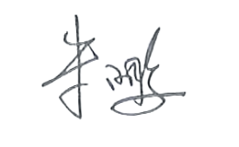
Signed :

General remarks:
The test results presented in this report relate only to the object (single inverter unit) tested and base on Low Voltage connected on small power station. The information about Generating Plant is not consider and tesing.
Installer and relevant persons shall comply with G100 and relevant standard and Grid Code in G100
Determination of the test result includes consideration of measurement uncertainty from the test equipment and methods.
The test results presented in this report relate only to the item tested. The results indicate that the specimen partially complies with standard”ER G100/2-1: 2022”. See general product information next for details information.
General product information:

The System comprising of smart meter providing control signals that communication with the inveter the RS485 interface in real time, the smart meter will install at the Connection Point and sense the power (measures the current and voltage) send to inverter, so that can control the net flow of electricity into the Distribution Network at the connection Point so as not to exceed the MEL.

Basic outline of the system as following:
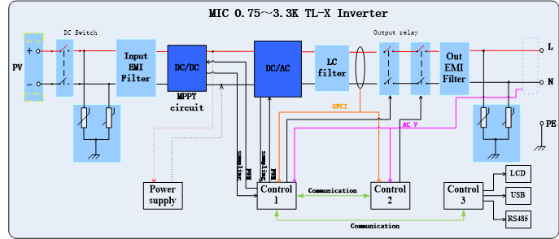

Factory information:
Factory and address: Guangdong Growatt New Energy Co., Ltd.
Growatt Industrial Park, No.17 Pingheng Road Pingtan Town,Huiyang District,Hui zhou,Guangdong, China
Test of setup-Injection testing:

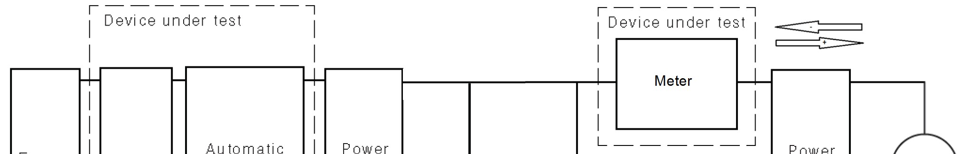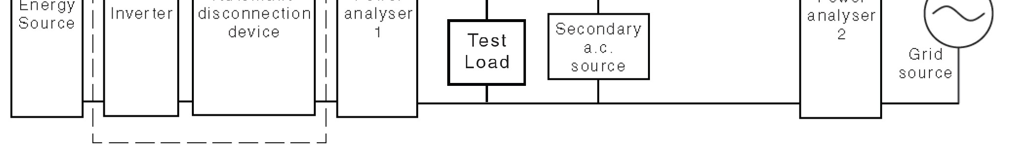

Export/Import capabilities
Export | Y | Import | N
Description of Operation
EREC G100 section Error! Reference source not found. requires a description of the CLS, and schematic diagram, to be provided to the Customer. Please provide that description and the diagram here.
The System comprising of smart meter providing control signals that communication with the inverter the RS485 interface in real time, the smart meter will install at the Connection Point and sense the power (measures the current and voltage) send to inverter, so that can control the net flow of electricity into the Distribution Network at the connection Point so as not to exceed the MEL.

Basic outline of the system as following:

How to set and control:
LCD display panel of inverter can be set to CLS enable and disable, or set percent of MEL 1, Power on. Stand-alone touch screen to find "set parameter".Double-click to enter.
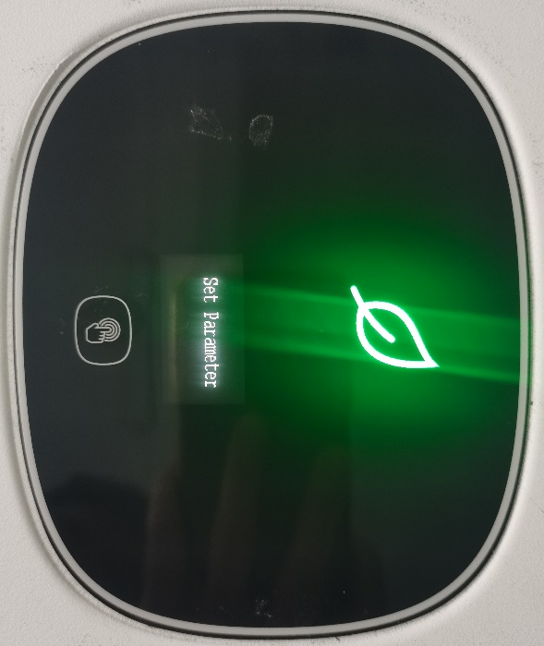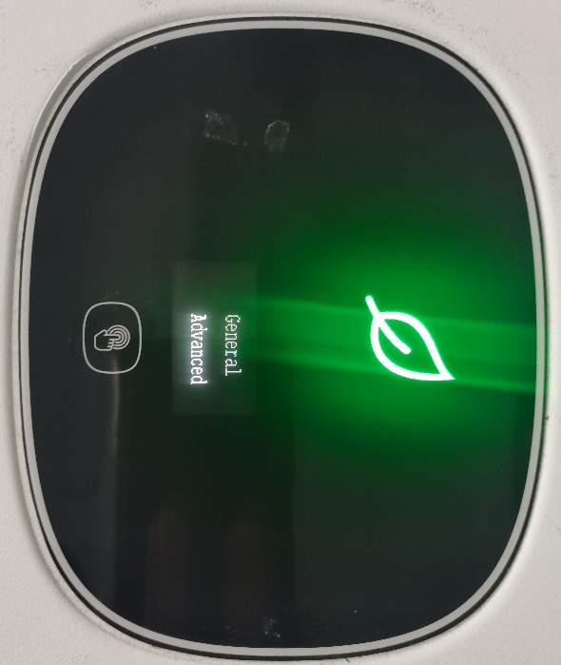
2, Double-click “advanced”, enter the password and enter. Click the touch screen to turn the page and find "exportlimit".Double-click off or “on” to enter.
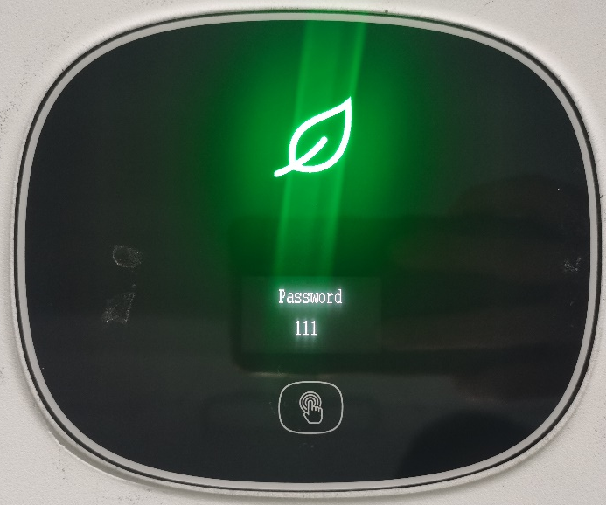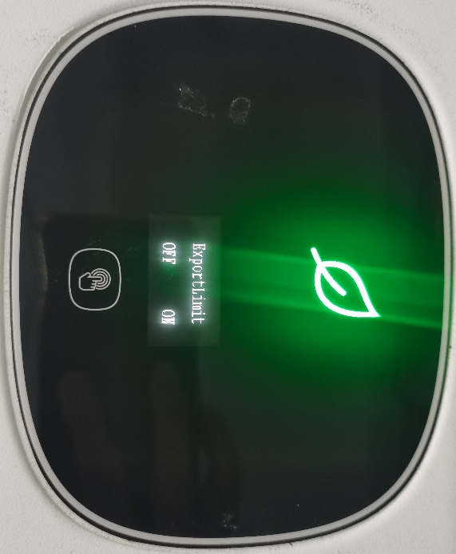

3, Double-click "meter" to set the exportlimit Rate.
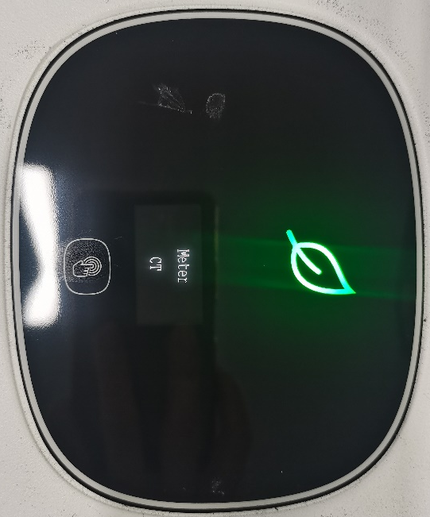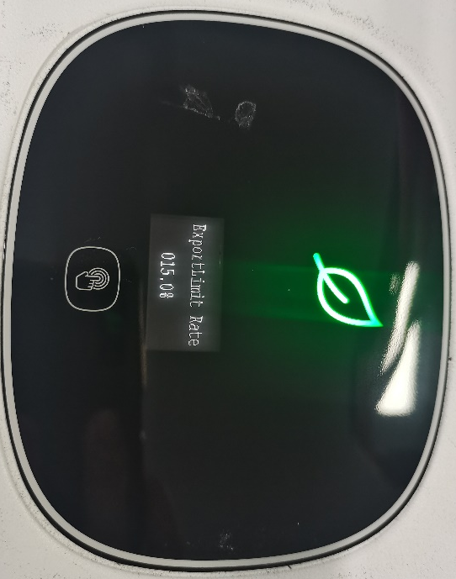
4, Return requires three consecutive clicks.That's the whole process of exporting limit function and setting MEL.
Note:
1, Once the export limit function is set OK, inverter will power off and then on.
2, This settings and control of CLS can not accessible to cunstomer, and it must be authorized and accessed by password.
Communications Media
Document the provisions made for the use of various communication media, and both the inherent characteristics and the design steps made to ensure security and reliability.
 | Communication mode | Baud rate | Communication object
 | RS485 | 9600 | Meter and inverter、 collector and inverter

 | ModBus | 38400 |  | Inverter internal communication
Cyber Security
Confirm that the Manufacturer or Installer of the CLS has provided a statement describing how the CLS has been designed to comply with cyber security requirements, as detailed in section Error! Reference source not found..
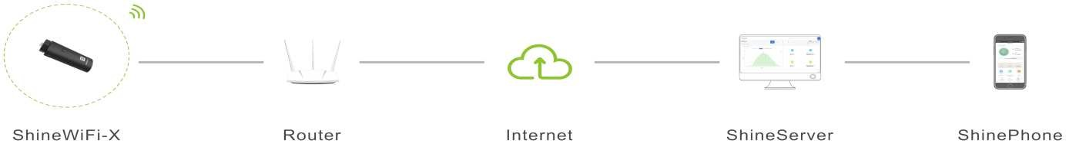
The following statements declared by Manufacturer 1)

ccc
Name | Meaning | Function | Location
MIC | Inverter | Monitor local load conditions, dispatch panel | Inverter
Monitoring | WIFI/GPRS/VPP | Monitoring device to realize remote monitoring function | Monitoring device
Router | Router device | transmission of data to cloud server, reception of  commands/settings from external stakeholder | Third-party device
Meter | External Power Meter/CT | meter at the MIN, and  possible meter at AC port of  third party generator/inverter, for power measures | Third-party device

Subject | Meaning | Operations
End-user | mobile device (App), PC ( web portal) | monitoring of historical data, settings for special functions
Service | PC (via web portal) | remote diagnosis, system behaviour monitoring, remote updates, remote settings

- All communications between internal components of the inverter, and supplied External Power Meter(s), take place via appropriate serial lines (RS485, CanBus) .
- The only communication port between the inverter and the outside is constituted by the monitoring device on the system; the communication between inverter and the outside world can take place via an Ethernet line, WiFi or GPRS router according to the customer's request.
- All communications between the Growatt server and the subjects/parties are cyber-protected by SSL technology.
- The cyber-security assessment of the Growatt was performed according to the ETSI EN 303 645 standard.
Power Quality Requirements
Where the CLS includes the power electronics that controls generation or loads (as opposed to the power electronics being included in Devices that are subject to their own power quality compliance requirements) please submit the harmonic and disturbance information here as required by EREC G5 and EREC P28.
The CLS does not include the power electronics.
Inverter will submit to comply with EREC G98 (less than 16A) and EREC G99
Please see separate report for details.
Fail Safe
CLS internal failure: please submit here the description of the internal Fail Safe design and operation. Please also document how it has been demonstrated, including the non-volatile recording of times and numbers of state 2 operations, and confirm the overall response of the CLS to this internal failure.
The energy meter (CLS) will communicate with control device (inverter) via through RS 485 interface, if any part of the energy meter failure, which will return to inverter shown communication fail, Once inverter received commnunication fail code, it will force into state 3 of fail-safe state and switch off the power to ensure the current does not exceed MEL through the connection point.
If the failure will cause the current tempory exceed the MEL into the state 2 operations, the CLS can also commnunicate with inverter for recording, the numbers of state 2 and time will record in the ROM of inverter, even if power off or removed, the ROM is still kept in MCU and waiting for inverter to start-up and reading the state again from the ROM.
The inverter will keep in the state 3 operation until the failure is fixed, once fixed then the CLS and inverter immediate reset into the state 1 operation.
Communication and power supply failures between Components and Devices. Please document here compliance with EREC G100 section Error! Reference source not found..
Component/Device number/description |  |  | Communication failure test |  | Power supply failure test
The energy meter (CLS) |  |  | -- |  | Power supply removed  (Inverter shown communication failure, which is forced into state 3, if the issue fixed, inverter and  CLS immediately reset into state  1 oeration)
Inverter |  |  | -- |  | MCU of inverter Power supply removed  (Inverter shutdown immediately, if the issue fixed, inverter and CLS immediately reset into state  1 oeration)
Communication between CLS and inveter |  |  | Remove/interrupt communication of RS 485 interface  (Inverter shown communication failure, which is forced into state 3, if the issue fixed, inverter and  CLS immediately reset into state  1 oeration) |  | --

Operational Tests
In accordance with EREC G100 section Error! Reference source not found. undertake the tests A to D to confirm correct operation in state 1 and state 2, that transition into state 3 occurs as required, and that behaviour in state 3 is also as required.
Test A
Nominal Export Limit (for type tests this will be at maximum, minimum and one intermediate setting) in Amp: |  |  |  |  |  | 50%In  (4.35A)
Nominal Import Limit (for type tests this will be at maximum, minimum and one intermediate setting) in Amp: |  |  |  |  |  | N/A
No | Starting level | Step value | CLS registers change in level? | CLS and/or Component and/or Device  initiates correct response of ≥ 5%? | Duration of step in test | Correct state  1/ state 2 operation
1 | 4.41A | 4.64A | Yes, Register in State 2 excursion | Yes | 58s | State 1
2 | 4.32A | 4.76A | Yes, Register in State 2 excursions | Yes | 58s | State 1
3 | 4.36A | 5.24A | Yes, Register in State 2 excursions | Yes | 58s | State 1
4 | -- | -- | -- | -- | -- | --
5 | -- | -- | -- | -- | -- | --
6 | -- | -- | -- | -- | -- | --
Test B
Nominal Export Limit: |  |  |  |  |  | 4.35A
Nominal Import Limit |  |  |  |  |  | N/A
No | Starting level | Step value | CLS registers change in level? | CLS and/or Component and/or Device  initiates correct response of ≥ 5%? | Duration of step in test | Correct state 3 operation
7 | 4.34A | 4.59A | Register in state 2 has exceeded 1 minute | Yes (The CLS will continue to drive the output of the Device away  from its original set point.) | 62s | State 3 (fail safe functionality)
8 | -- | -- | -- | -- | -- | --
Test C
Nominal Voltage |  |  |  |  |  | 230V
No | Starting voltage | Step value | CLS registers change in voltage? | CLS and/or Component and/or Device  initiates correct response? | Duration of step in test | Correct state  1/ state 2 operation
9 | 230.1V | 257.8V | Yes, Register in State 2 excursion | Yes | 58s | State 1
Test D
Nominal Voltage |  |  |  |  |  | 230V
No | Starting voltage | Step value | CLS registers change in voltage? | CLS and/or Component and/or Device  initiates correct response? | Duration of step in test | Correct state 3 operation
10 | 230.2V | 257.9V | Yes, Register in state 2 has exceeded 1 minute | Yes | 62s | State 3(fail safe functionality)

Test E
Nominal Voltage |  |  |  |  |  | 230V
No | Starting voltage | Step value | CLS registers change in voltage? | CLS and/or Component and/or Device  initiates correct response? | Duration of step in test | Correct state 1/ state 2 operation
11 | 230.2V | 199.3V | Yes, Register in State 2 excursion | Yes | 58s | State 1
Test F
Nominal Voltage |  |  |  |  |  | 230V
No | Starting voltage | Step value | CLS registers change in voltage? | CLS and/or Component and/or Device  initiates correct response? | Duration of step in test | Correct state 3 operation
12 | 230.1V | 199.6V | Yes, Register in state 2 has exceeded 1 minute | Yes | 62s | State 3(fail safe functionality  )
Test G
Nominal Voltage |  |  |  |  |  | 230V
No | Starting voltage | Step value | CLS registers change in voltage? | CLS and/or Component and/or Device  initiates correct response? | Duration of step in test | Correct state 1/ state 2 operation
13 | 230.5V | 262.8V | Yes, Register in State 2 excursion | Yes | 0.98s | State 1
Test H
Nominal Voltage |  |  |  |  |  | 230V
No | Starting voltage | Step value | CLS registers change in voltage? | CLS and/or Component and/or Device  initiates correct response? | Duration of step in test | Correct state 3 operation
14 | 230.4V | 262.7V | Yes, Register in state 2 has exceeded 1s | Yes | 1.02s | State 3(fail safe  functionality  )
Test J
Nominal Voltage |  |  |  |  |  | 230V
No | Starting voltage | Step value | CLS registers change in voltage? | CLS and/or Component and/or Device  initiates correct response? | Duration of step in test | Correct state 1/ state 2 operation
15 | 230.3V | 178.1V | Yes, Register in State 2 excursion | Yes | 0.98s | State 1
Test K
Nominal Voltage |  |  |  |  |  | 230V
No | Starting voltage | Step value | CLS registers change in voltage? | CLS and/or Component and/or Device  initiates correct response? | Duration of step in test | Correct state 3 operation
16 | 230.2V | 178.2V | Yes, Register in state 2 has exceeded 1s | Yes | 1.02s | State 3(fail safe functionality  )

State 3 Reset
These tests are to demonstrate compliance with section EREC G100 Error! Reference source not found..
Please document how the reset from state 3 to state 1 has been demonstrated. Please include how the reset is achieved.
Please confirm that for CLSs to be installed in Domestic installations three (3) resets causes lockout or that for non-domestic installations lockout can only be reset after four hours. Please explain how lockout is reset.
When the ROM of inverter had been recorded the following criteria, the inverter will enter into state 3 operation and locked out immediately
1, A single excursion into state 2 operation that persists for more than 1 minute
2, There are more than three excursions (each of more than 10s and less than 1 minute) into state 2 operation in any 24-hour period
3, The time between any two consecutive excursions into state 2 operation of greater than 10s is 10 minutes or less (measured from the time of re-entry into state 1 operation from state 2 operation following the first excursion )

If the state 3 is locked out, it should reset by Manufacturers or Installers via remote controlled, or the manuafacturers will provide a facility APP to reset.
It should be sent a command to inverter via remote or facility APP to set 1244 of MCU to 0, set 1245 of MCU to 1, the MCU will clear out the records of ROM and exit the state 3 operation.

This CLS and inverter are only valid for Domestic installations, when 3 resets has been exceeded in any 30-day period. which will lead to lock out in state 3 operation too, the reset should be followed the same operation as above.

(End of Report)

